# Releases

Contents

Releases 1

Running Normal Release 1

Running a Dummy Release 1

How to Amend Filter Criteria for Dummy Release 4

## Running Normal Release

There are run automatically overnight, but to run it again (probably because it failed) go the Build and Release tab in TFS. Select Releases tab from LHS panel. Select the required Release Definition (e.g. Portal Acceptance Tests). Click on the 3 dots. Click on +Release. Enter a Release Description and click on Create.

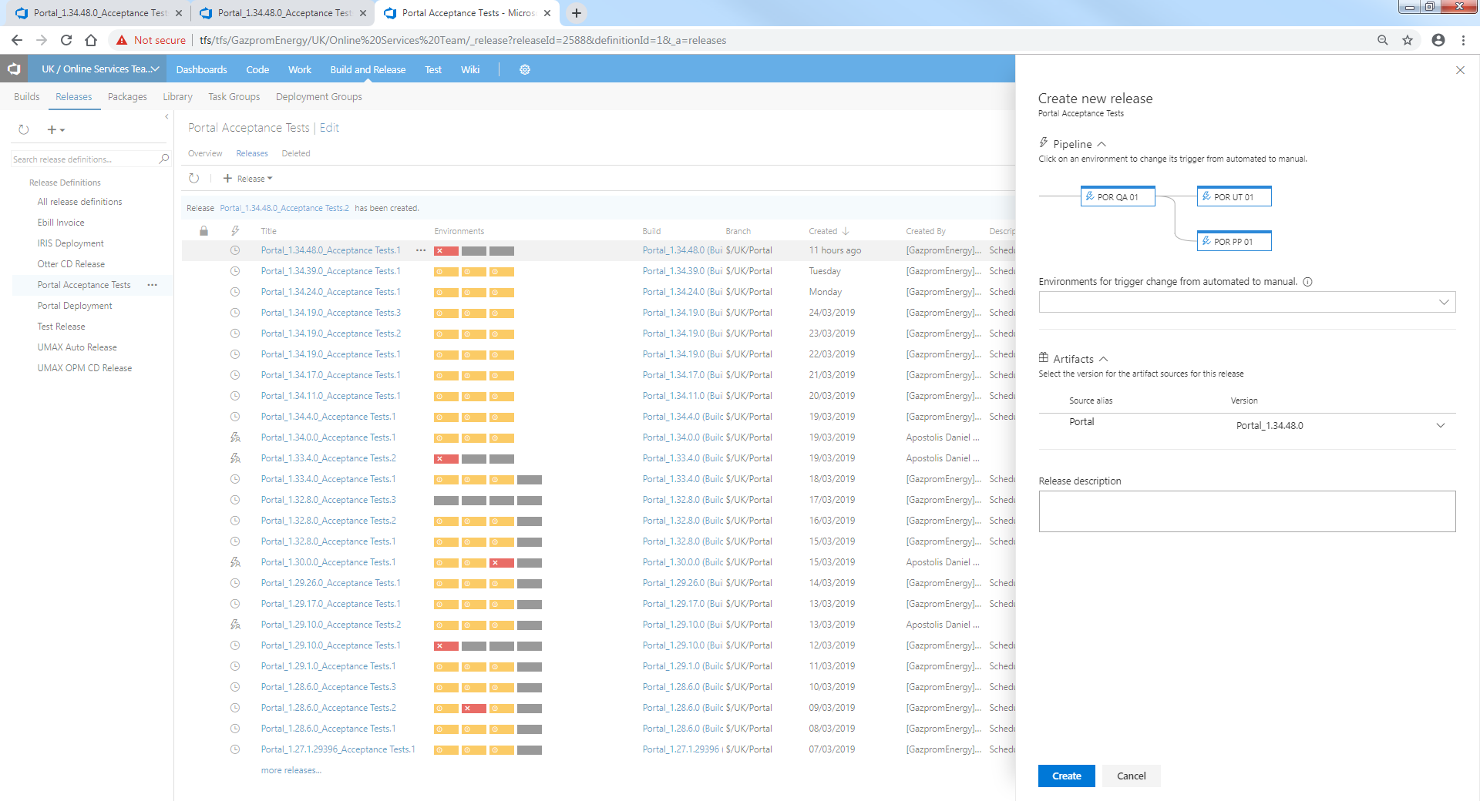

## Running a Dummy Release

This is similar to the overnight releases, the main difference being that (a) you can trigger it yourself rather than waiting for the overnight run and (b) it is faster because you are only running a small number of tests.

In order for a test to be included in this release, you need to annotate it with @Dummy in the feature file.

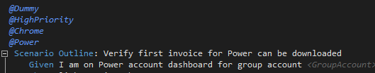

To create a new instance of the Dummy Release Definition (it is the instance that actually runs)

Click on the 3 dots after Portal Acceptance Tests Dummy then click on +Release

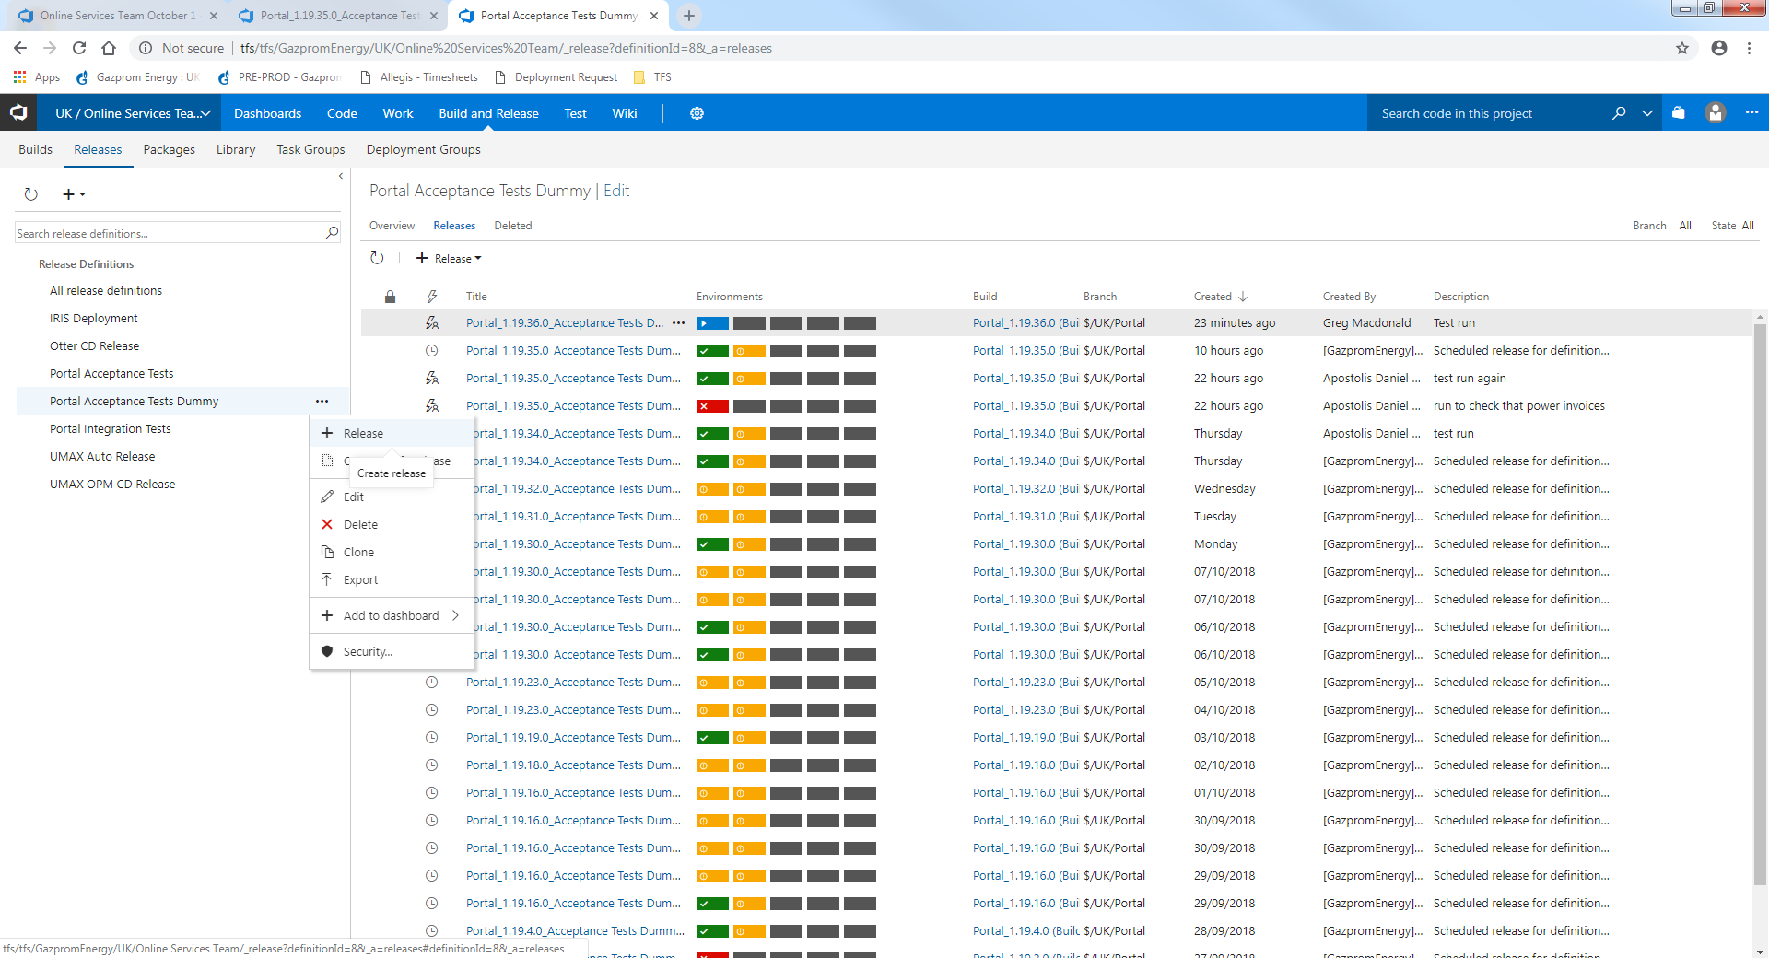

Give it a Release Description and click on Create

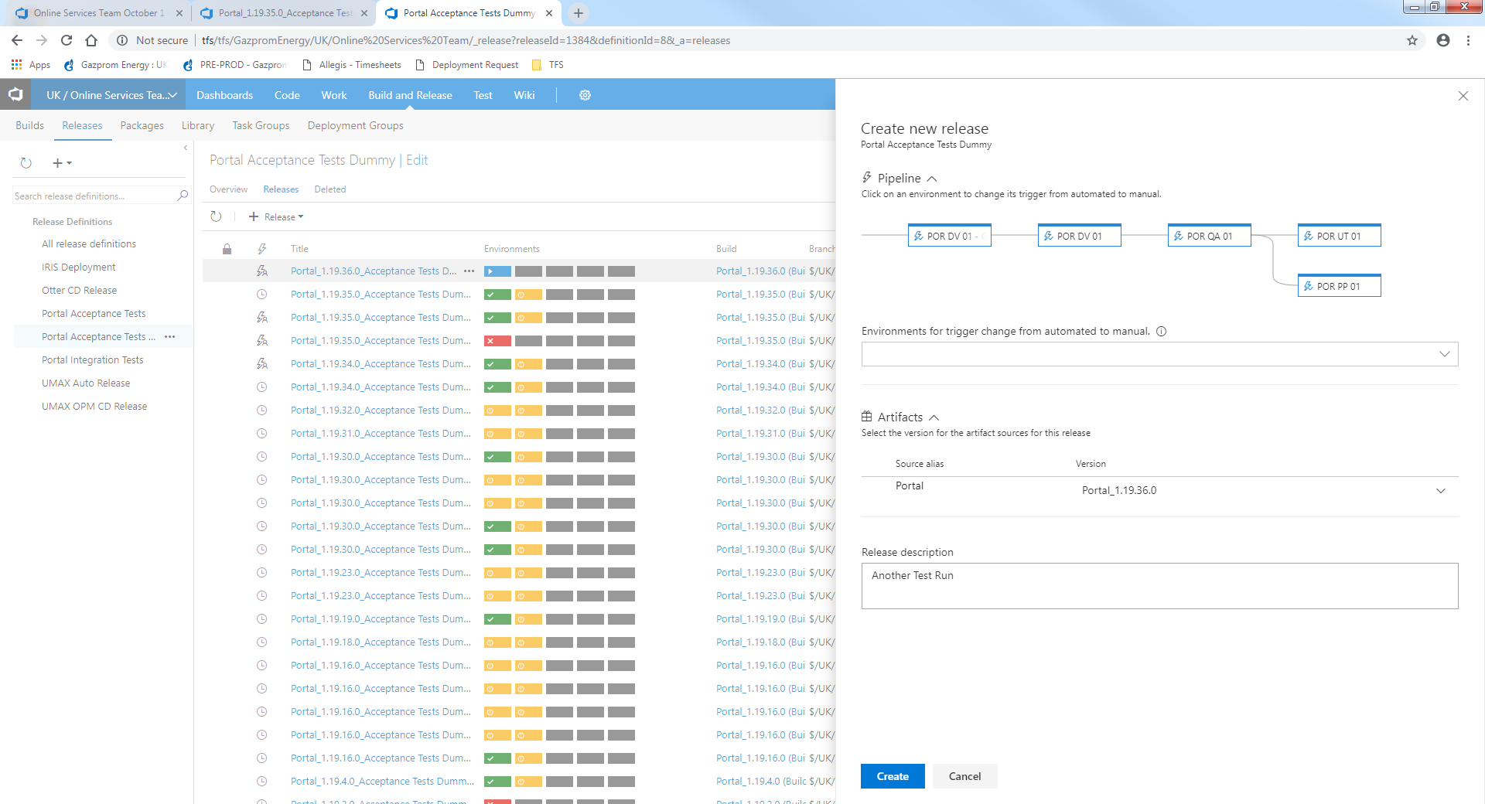

After a few seconds it will appear at the top of the list of releases (or press f5 to hurry it up)

Click on it to open it

It will then start running through each of environment’s tasks in the defintion. As shown below, it is NOT a particularly fast process (the first set of tasks too almost half an hour)

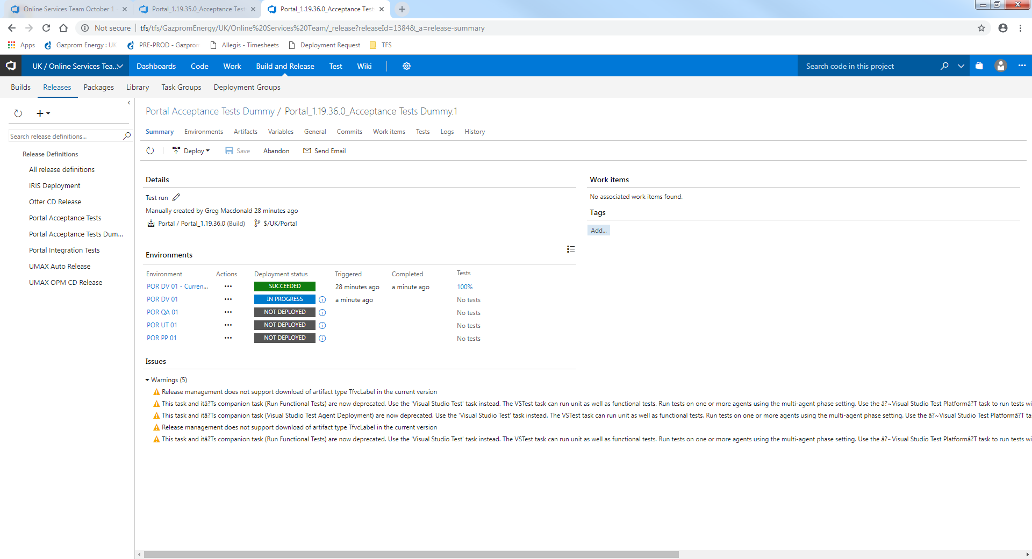

## How to Amend Filter Criteria for Dummy Release

In TFS, select Build and Release -> Releases

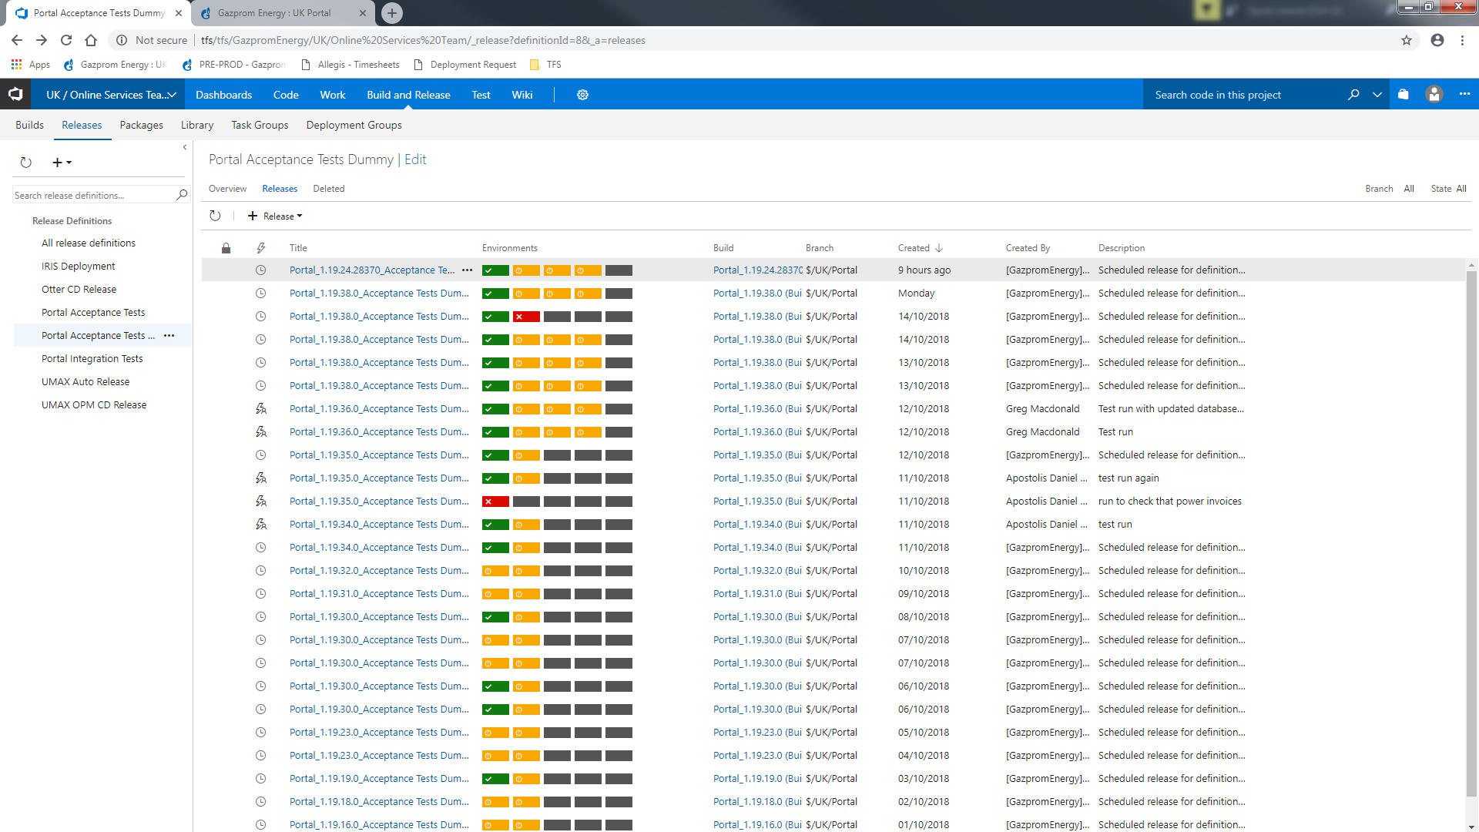

Click on the 3 dots beside Portal Acceptance Tests Dummy and select Edit

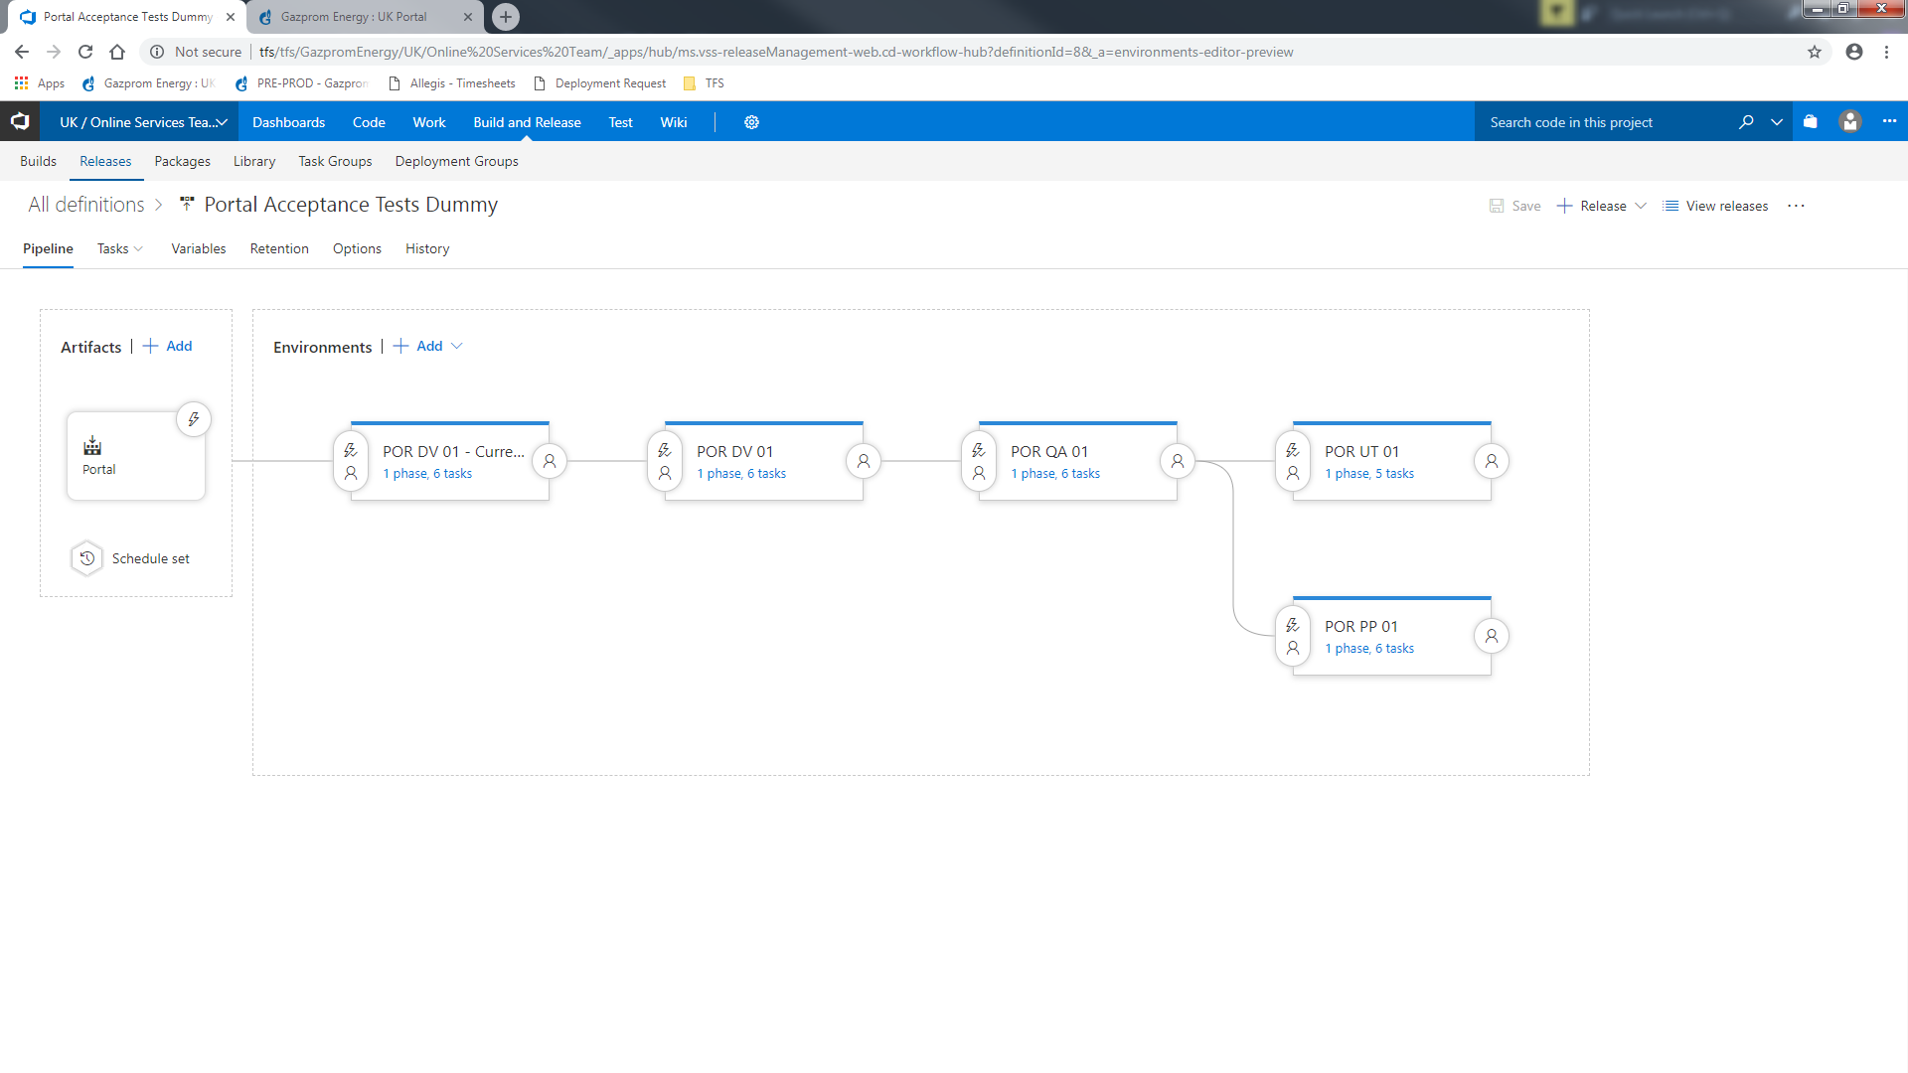

Click on the blue text in the POR QA 01 box

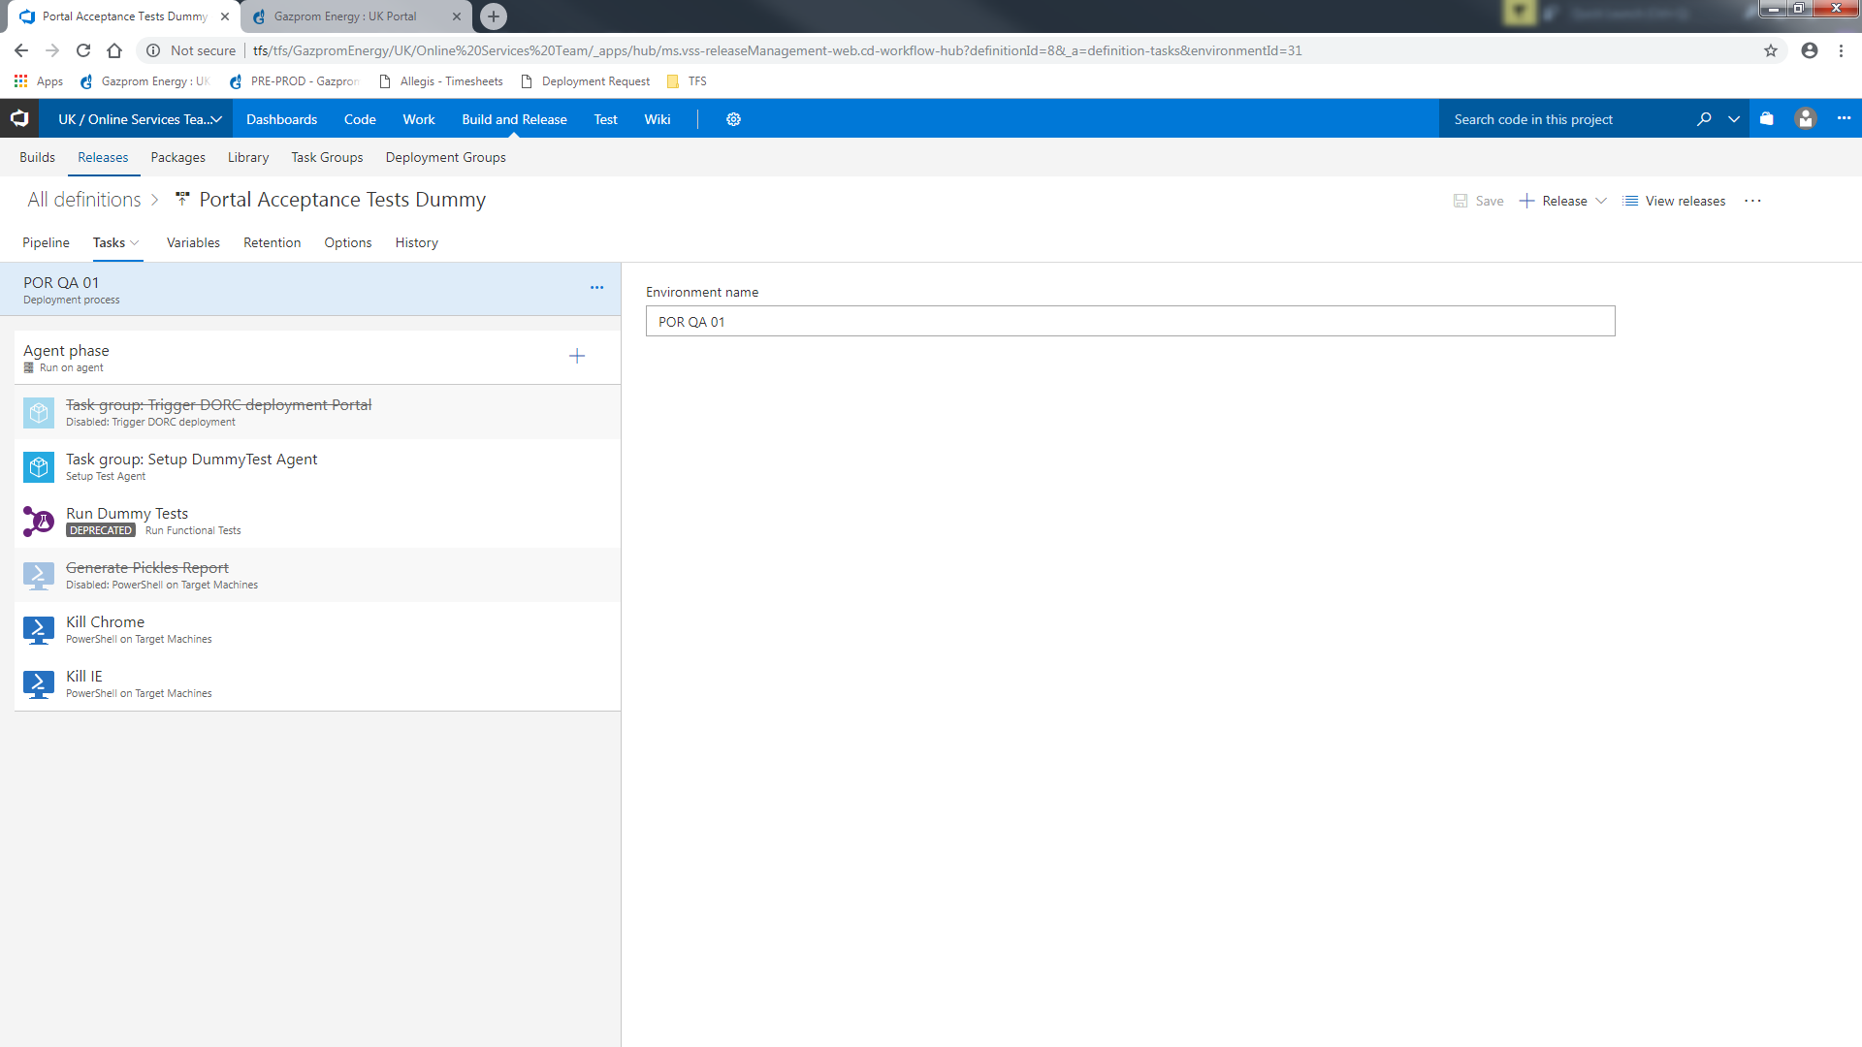

Click on Run Dummy Tests

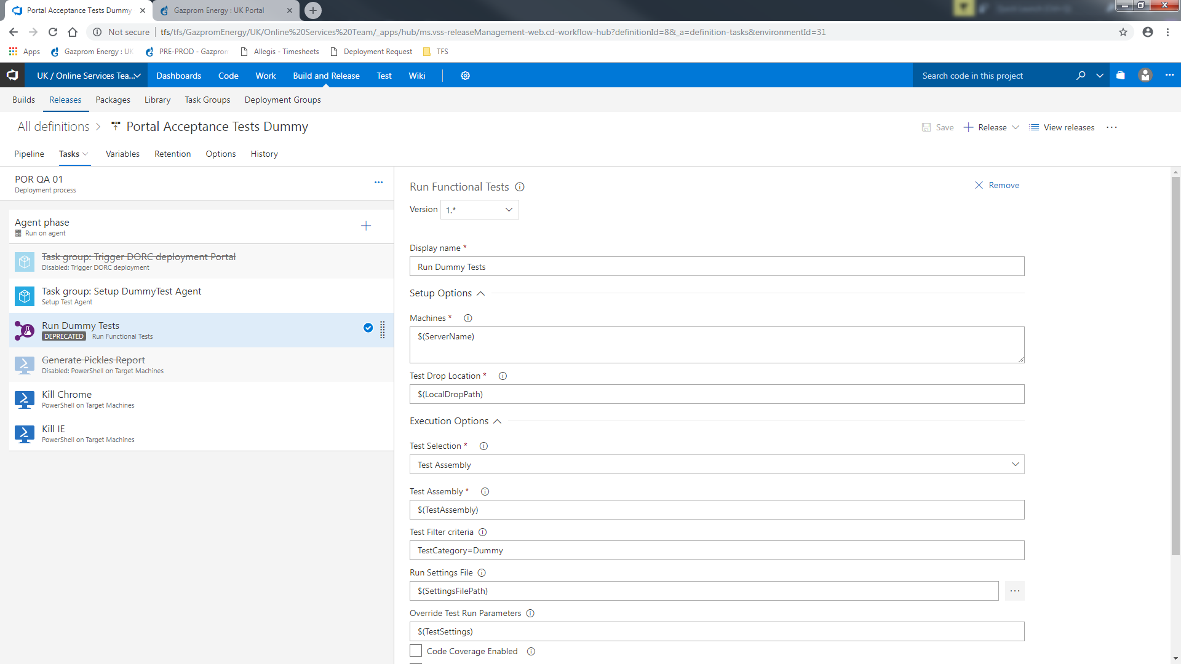

Amend the values in Test Filter Criteria to the new value that you need.

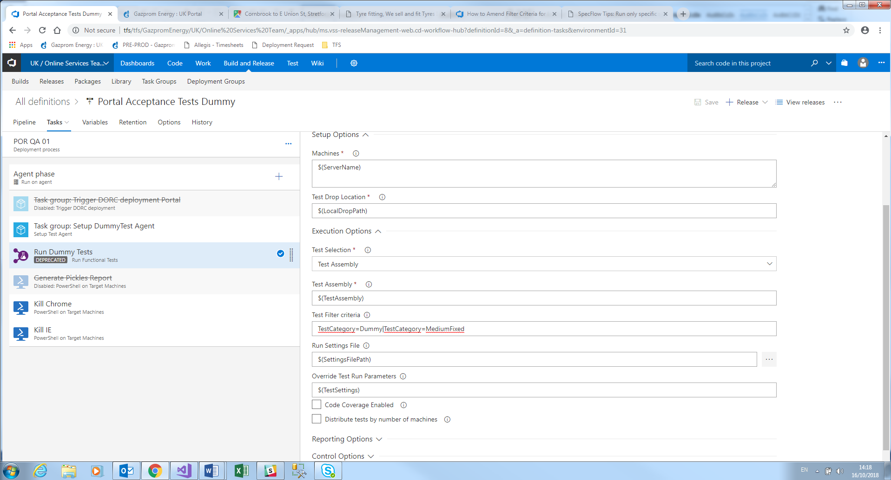

Click on Save and add a comment